

A Project Report

On

**“Kisan Buddy”**

Batch Details

|  |  |  |
| --- | --- | --- |
| Sl. No. | **Roll Number** | **Student Name** |
| 1 | 20211CIT0098 | Vinay Gowda R |
| 2 | 20211CIT0137 | Devika N |
| 3 | 20211CIT0141 | Keerthana R |
| 4 | 20211CIT0144 | Sushmitha N C |
| 5 |  |  |

**School of Computer Science,**

**Presidency University, Bengaluru.**

Under the guidance of,

Dr. Sharmasth Vali Y

School of Computer Science,

Presidency University, Bengaluru

**CONTENTS**

1. Introduction about Project
2. Literature Review
3. Objectives

## Methodology

1. Timeline for Execution of Project
2. Expected Outcomes
3. Conclusion
4. References
5. **INTRODUCTION**

*General Introduction*

Agriculture is the backbone of the Indian economy, employing nearly 60% of the workforce. Despite its importance, farmers face significant challenges, including climate change, pest attacks, market volatility, and limited access to timely information. *Kisan Buddy* is a mobile application designed to empower farmers by providing real-time information and resources tailored to their needs. This platform integrates various agricultural services, including weather forecasts, pest management, market prices, and community support, aiming to enhance productivity and income for farmers.

Introduction to the domain of the Problem statement chosen.

The agricultural sector is evolving, with technology playing a critical role in modern farming practices. However, many farmers still rely on traditional methods and lack access to crucial information. *Kissan Buddy* addresses this issue by creating a one-stop solution that leverages technology to deliver essential agricultural insights. The project aims to educate farmers, improve decision-making, and foster a sense of community among agricultural stakeholders.

By using Kisan Buddy, farmers can make data-driven decisions, optimize resources, and increase productivity. Agriculture remains the backbone of India's economy, with over 60% of the population relying on it for their livelihood. However, despite technological advancements, a significant portion of farmers continue to struggle with low yields, unpredictable weather patterns, and market fluctuations. "Kisan Buddy" seeks to address these challenges by offering farmers an easy-to-use mobile platform that provides personalized recommendations for crop management, real-time weather updates, and access to market rates for their produce. Additionally, the platform will integrate voice-assisted features to cater to farmers with varying literacy levels, making it inclusive and accessible. Kisan Buddy aims to modernize the agricultural sector and enable farmers to make informed, data-driven decisions to maximize their productivity and profits.

1. **LITERATURE REVIEW**

|  |  |  |  |
| --- | --- | --- | --- |
| SL.NO | Title | Year | Authors |
| 1. | Farmers Buddy: Farmers Online Selling Application | 2019 | C. Rama Mohan  Ch. Sandeep Kumar  Narasimha Chowdary  K. V. Sai Ganesh  Ch. Viswa Narahari |
| 2. | Crop Guidance and Farmer’s Friend  – Smart Farming using  Machine Learning | 2020 | Tanvi Daware  Pratiksha Ramteke  Uzma Shaikh  Smita Bharne  Ramrao Adik |
| 3. | Survey on Development of an  Android Application for  Kisaan(Farmers) | 20192 | Prof. Ashvini Bais  Shreya Kumari  Vaishnavi Khabarde |
| 4. | Farmer Buddy | 2020 | Monali Nimje  Pranali Wankhede  Tulsiramji Gaikwad  Prof. Rajesh |
| 5. | Kisan Seva Kendra a Web-based  Application | 2018 | Prof. Kamlesh Kelwade  Prof. Naveed Zeeshan  Aadil Sheikh  Amit Wasnik  Fuzail Khan  Jay Moundekar  Rehan Raza Baig  Tejas Lamsoge |
| 6. | Kisan Mitra: A Farming Assistance  Application using  Ionic Framework | 2021 | Sayali Sunil Tandel  Shraddha Chavan Abhijeet Kamble  Deepti Chandran |
| 7. | "PAU Kisan App: A Mobile Based  Agricultural Advisory System" | 2020 | Singh,  J Kumar  Sharma P |

[1] The Farmers Buddy aims to address the limitations of existing system by eliminating the middleman, user-friendly platform that supports farmers . The application allows farmers to sell their produces, add products, and monitor orders and requests. Farmers can efficiently handle product pricing, view costumer purchase requests, and manage their orders. Customers benefit from an intuitive interface to browse products, place orders, and provide feedback, ensuring a seamless and interactive experience. The farmers Buddy application is designed to bridge this gap by providing a digital platform that connects farmers directly with consumer

[2] Current innovation in farming is somethingother than the utilisation of versatile applications or anequipment framework to robotize repetitive cycles andlessen reliance on human work.This prediction willhelp farmers choose the appropriate crops for their farmbased on soil type, temperature, humidity, water level,depth of spacing, soil pH, season, fertiliser, andmonths. Rising technologies are used to improve the productivity of the crops by changing traditional farmingto efarming. This could be done with the help of machine learning algorithms that are found to be an efficient methodologyfor predicting the appropriate crop.

[3] This paper presents the mobile application for the farmers. Today, everyone is familiar with mobile devices. Nowadays farmers are facing problem due to inappropriate information available. Mobile is the new way through which farmers can easily get information through smartphones. Also include farmers and people from rural areas. Mobile plays an important role in the life of farmers as well as other people. Farmers, who depended on clouds for rain, are now looking into the Android application for their solution towards the cultivation of crops in today's modern agricultural world .

[4] Farmer Buddy is an open discussion portal develops using Android programming language with the system database. This project is useful for farmers and agricultural student to obtain information regarding various crops, tools used by the farmers, also provide one of the platforms for online selling and buying of the different types of grains and the tools. Also provide the desire cost to the user or farmer. The cost is decided by the expert system. By using this application the tools can be available on second hand also. One expert system is organized to decide the proper cost of the grains that are selling by the farmer.

[5] As we move into the modern era of technology, engineering-related applications have the potential to significantly enhance society. With smartphones being a ubiquitous tool for completing daily tasks such as shopping, bill payments, and work management, we are immersed in a world of endless possibilities and convenience. The idea of this project is to add its features into the lives of the people so that the food they buy can be bought directly from the farm and this would enable profits to reach farmers directly. In India, the supply chain for farm products often involves intermediaries, leading to indirect sales for farmers. The farmer's direct interaction with customers translates to affordable prices for their products, benefiting both parties. This mutually beneficial arrangement allows customers to save money while enabling farmers to earn the profits they deserve.

[6] Rural subsistence farmers across India experience difficulties in gathering relevant and up-to-date agriculture information. This research aims to develop a mobile application for broadcasting agriculture information to rural subsistence farmers. This is a complete system that advises the farmers about what crops to grow and in which region prediction of suitable soil to the crop type seed availability as well as an interface that connects the farmer to the supplier and vice versa. Kisan Mitra helps the farmers working with the motive of greater profitability by direct communication between farmers to supplier playing a vital role in the enhancement of farmers .

[7] This study evaluates the effectiveness of PAU Kisan App, a mobile-based agricultural advisory system. The app provides information on crop management, disease/pest management, and agricultural machinery. Results show that farmers find the app useful, but face issues with navigation and content depth. Recommendations include improving user interface and expanding content.

*Existing Methods*

1. **Mobile Apps for Farmers**

- Advantages: User-friendly interfaces and real-time updates.

- Limitations: Some apps have limited regional applicability and may not support local languages.

1. **SMS-based Information Systems**

- Advantages: High reach, especially in areas with low smartphone penetration.

- Limitations: The format is restrictive, and interactivity is minimal.

1. **Social Media Groups**

- Advantages: Farmers can share experiences and advice quickly.

- Limitations: The quality of information can vary, leading to potential misinformation.

1. **Government Initiatives**

- Advantages: Reliable data from official sources.

- Limitations: Often slow to implement and access can be bureaucratic.

1. **Research Institutions**

- Advantages: Access to cutting-edge research and agricultural techniques.

- Limitations: Information can be overly technical for the average farmer.

**6. E-commerce Platforms**

- Advantages: Direct market access and better pricing strategies.

- Limitations: Dependence on internet connectivity and logistics infrastructure.

**7.Drone Technology**

- Advantages: High precision in monitoring and managing crops.

- Limitations: High initial costs and the need for technical training.

**8.Agricultural Forums**

- Advantages: Peer-to-peer learning and knowledge sharing.

- Limitations: Lack of moderation can lead to the spread of unreliable information.

*Gaps in Existing Literature*

The existing methods highlight significant gaps, including:

- A lack of integration among various services and information sources.

- Limited accessibility of advanced technologies for small-scale farmers.

- Insufficient focus on local conditions and languages in agricultural apps.

- Minimal community engagement in existing platforms.

**3. OBJECTIVES**

Based on the observations from the literature survey, the following objectives are proposed:

1. **Develop a Comprehensive Mobile Application:** Create a user-friendly platform that aggregates various agricultural information, catering specifically to local farmers' needs.

2. **Real-Time Alerts and Notifications**: Implement features that provide instant alerts about weather changes, pest outbreaks, and market trends.

3. **Marketplace Connectivity**: Introduce a marketplace feature that allows farmers to sell their produce directly to consumers, minimizing middlemen.

1. **Educational Resources:** Offer a repository of best practices, tutorials, and tips in accessible formats to enhance farmers' knowledge and skills.
2. **Accessibility for All:** To ensure that every farmer, regardless of their literacy or location, can access crucial agricultural information.
3. **Real-Time Data:** To provide farmers with real-time weather forecasts, market prices, and farming tips that will help them make timely decisions to improve productivity.
4. **Localized and Personalized Advice:** To use data-driven algorithms to offer cropspecific and region-specific advice that maximizes yield.
5. **Promote Sustainable Farming Practices:** To encourage farmers to adopt sustainable farming practices that will benefit both the environment and their income over the long term.
6. **Empowerment through Technology:** To bridge the gap between rural farmers and modern agricultural technology through an easy-to-use platform that can be accessed via basic smartphones.

**EXPERIMENTAL DETAILS/METHDOLOGY**

*Hardwares and Softwares used:*

**Hardware**: Smartphones (Android and iOS), tablets, and servers for cloud storage and processing.

**Software**: Development platforms like Android Studio and Xcode, backend technologies such as Node.js and Firebase, and design tools like Figma.

**4. METHODOLOGY**

**- DESIGN PROCEDURE**

1. **Requirement Analysis**: Conduct surveys and interviews with farmers to gather insights on their challenges and needs.

2. **Wireframing and Prototyping**: Create wireframes to visualize the app's layout and flow, followed by developing prototypes for initial testing.

3. **User Interface Desig**n: Focus on intuitive design principles that cater to users with varying levels of tech-savviness.

4. **Backend Development**: Build the server-side logic to handle data storage, processing, and retrieval.

5. **Integration of Features**: Develop and integrate features like weather updates, pest management tools, and a marketplace.

6. **Testing and Quality Assurance**: Conduct rigorous testing phases, including unit tests, user acceptance tests, and beta testing with real users.

7. **Deployment and Launch**: Release the application on relevant platforms and promote it through workshops and agricultural fairs.

*User Engagement Strategies*

- **Workshops and Training**: Organize sessions to demonstrate the app's functionalities to farmers.

- **Feedback Mechanism**: Implement feedback forms within the app to continually gather user insights for improvements.

- **Community Building**: Foster online forums or groups where users can share experiences and suggestions.

**5. OUTCOMES**

1**. Enhanced Access to Information**: Farmers will have easy access to essential agricultural data, helping them make informed decisions.

2. **Increased Productivity**: Timely alerts about weather and pests will enable proactive measures, boosting crop yields.

3. **Direct Market Access:** The marketplace feature will facilitate better pricing and sales for farmers' products.

4. **Knowledge Improvement**: Educational resources will empower farmers with modern techniques and practices.

*Performance Metrics*

- User adoption rates (number of downloads and active users).

- Feedback ratings and user satisfaction surveys.

- Increases in crop yields reported by users.

- Volume of transactions through the marketplace feature.

**6. TIMELINE OF THE PROJECT/ PROJECT EXECUTION PLAN**

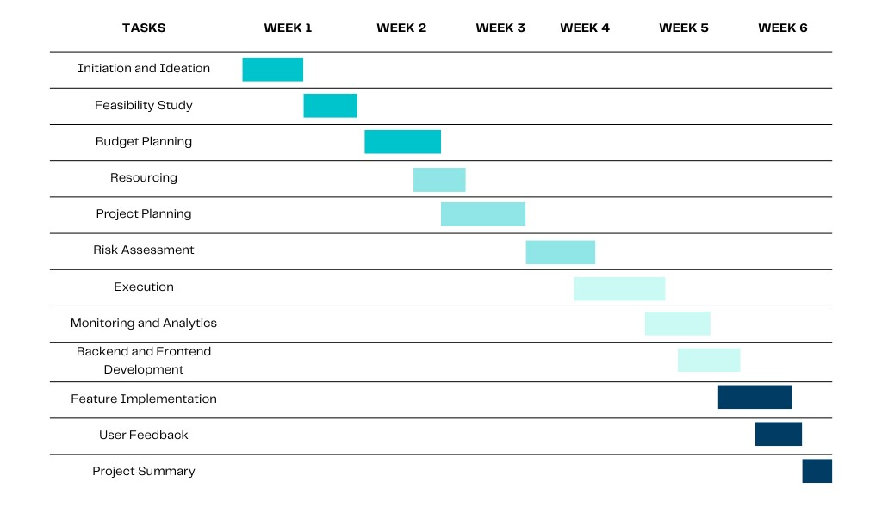

**7. CONCLUSION**

The Kisan Buddy project stands to revolutionize the way farmers access information and resources. By leveraging technology, the application not only aims to improve agricultural productivity but also seeks to empower farmers economically and socially. The project is positioned to create a positive impact on the agricultural landscape, promoting sustainable practices and enhancing the livelihoods of farmers.

*Future Scope*

Future enhancements could include:

- Incorporating AI for predictive analytics in crop management.

- Expanding features for sustainable farming practices.

- Collaborating with agricultural experts for real-time consultations.

- Developing multi-language support for wider accessibility**.**

**REFERENCES**

[1] Farmers Buddy: Farmers Online Selling Application C. Rama Mohan1 | Ch. Sandeep Kumar 2 | K. L. Narasimha Chowdary 3 | K. V. Sai Ganesh4 | Ch. Viswa Narahari 5 | 1Associate Professor, Department of Computer Science and Engineering, Narayana Engineering College, Nellore, Andhra Pradesh, India

[2] Survey on Development of an Android Application for Kisaan(Farmers) [1] Prof. Ashvini Bais, [2] Shreya Kumari, [3] Vaishnavi Khabarde [1] Department of Computer Science and Engineering,[2] Department of Computer Science and Engineering,[3] Department of Computer Science and Engineering

[3] Farmer Buddy Monali Nimje1 ,Pranali Wankhede2 1,2UG Scholars, Department of Computer Science & Engineering, Tulsiramji Gaikwad Patil College of Engineering & Technology, Nagpur Prof. Rajesh Babu1 1Professor, Department of Computer Science, Tulsiramji Gaikwad Patil College of Engineering & Technology, Nagpur

[4] E-Commerce of Agricultural Product Selling Using AndroidApp P.Venkatesh assistant Professor, Dept. of CSE, Adhiyaaman College of engineering, Tamil Nadu, India

[5] An Android Based E-Commerce Application for Farmers Ayush Kumar Department of Electronics and Telecommunication, College of Engineering, Bharati Vidyapeeth (Deemed to Be University) Pune, Maharashtra, India Anchal Thakre Department of Electronics and Telecommunication, College of Engineering, Bharati Vidyapeeth (Deemed to Be University) Pune, Maharashtra, India Sudhir Kadam Department of Electronics and Telecommunication, College of Engineering, Bharati Vidyapeeth (Deemed to Be University) Pune, Maharashtra, India

[6] FARMER PRODUCT DIRECT SELLING SYSTEM P. Madhan kumar1, Dr.E.Ramadevi, M.C.A.,M.Phil., Ph.D.,2 Student, PG Department of Computer Science, NGM College, NGM College,Pollachi, Tamil Nadu,India1. Assistant Professor, PG Department of Computer Science, NGM College,Pollachi, Tamil Nadu,India2.